**AI BASED**

**DIABETES PREDICTION**

**SYSTEM**

**Phase 5: Report Submission**

|  |  |
| --- | --- |
| Date | 10-10-2023 |
| Team ID | Proj-212176-Team-2 |
| Project Name | AI Based Diabetes Prediction. |
| Maximum Mark |  |



**INDEX:**

|  |  |  |
| --- | --- | --- |
| **S.NO** | **CONTENT** | **PAGE NO** |
| 1. | Abstract | 2 |
| 2. | Introduction | 3 |
| 3. | Literature Survey | 4 |
| 4. | Problem Definition | 5 |
| 5. | Design Thinking | 7 |
| 6. | Innovation to & Problem Solving | 11 |
| 7. | Importing Dataset & Performing Data Cleaning and Data Analysis | 14-20 |
| 8. | Data Visualization | 21 |
| 9. | Model Development & Evaluation | 22 |
| 10. | Code Sample | 25 |
| 11. | Output Screenshot | 27 |
| 12. | Conclusion and Future Enhancement | 32 |

**List of figures:**

|  |  |
| --- | --- |
| **Figures** | **Page No.** |
| Figure(a) | 10 |
| Figure(b) | 12 |
| Figure(c) | 29 |
| Figure(d) | 29 |
| Figure(e) | 30 |
| Figure(f) | 30 |
| Figure(g) | 31 |
| Figure(h) | 31 |
| Figure(i) | 32 |
| Figure(j) | 33 |

**Abstract:**

The article states that machine learning can help predict which patients will develop diabetes. The study was conducted by researchers at the University of Toronto and analyzed data of 2.1 million people living in Ontario to identify potential predictors of diabetes. [Another research paper titled “Type 2 Diabetes with Artificial Intelligence Machine Learning: Model Building and Evaluation”](https://bing.com/search?q=abstract+ai+based+diabetes+prediction) presents a study on the development and evaluation of machine learning models for type 2 diabetes prediction.

The authors used three real-life diabetes datasets and nine feature selection algorithms for the evaluation. They compared the accuracy, F-measure, and execution time for model building and validation of the algorithms under study on diabetic and non-diabetic individuals. The performance analysis of the models is elaborated in the article.

[Another research paper titled “Artificial Intelligence in Current Diabetes Management and Prediction”](https://link.springer.com/article/10.1007/s11892-021-01423-2) provides an overview of the current state of AI-based diabetes prediction and management. It also highlights the challenges faced in developing and implementing AI-based diabetes prediction models.

This study proposes a machine learning approach for predicting the risk of diabetes using an AI model trained on a large dataset of patient records. The model utilizes various features such as age, BMI, blood pressure, and glucose levels to accurately predict the likelihood of developing diabetes. The results show promising accuracy and potential for early detection and prevention of diabetes through AI technology.

**Introduction:**

* AI-based diabetes prediction is a field that aims to use artificial intelligence to analyze health data and identify who is at risk of developing type 2 diabetes.  [In this review, we introduce AI/ML-based medical devices and prediction models regarding diabetes. Recent findings in the field of diabetes include several AI-/ML-based medical devices and regarding automatic retinal screening, clinical diagnosis support, and patient self-management tool have already been approved by the US Food and Drug Administration.](https://link.springer.com/article/10.1007/s11892-021-01423-2)
* I found a research paper titled “Data visualization and pre-processing techniques based Diabetes Prediction System”.The paper presents a diabetes prediction system that uses data visualization and pre-processing techniques to predict diabetes. The system is designed to help doctors and patients make informed decisions about diabetes management.
* The authors used the PIMA dataset and applied data visualization techniques to identify the most important features for diabetes prediction. They then used pre-processing techniques to normalize the data and applied machine learning algorithms to predict diabetes. The authors also used data visualization techniques to visualize the results of the machine learning algorithms. You can find more information about AI-based diabetes prediction in my previous responses.

**Literature Survey:**

A literature survey for AI-based diabetes prediction involves researching and reviewing existing studies, articles, and papers related to using artificial intelligence for predicting diabetes. It helps gather insights, understand the current state of research, and identify gaps or areas for improvement. It's like exploring a treasure trove of knowledge to inform and guide your own AI-based diabetes prediction project.

When conducting a literature survey for AI-based diabetes prediction, you'll want to focus on key aspects such as the types of AI algorithms used, the datasets utilized, the performance metrics employed, and the accuracy of the predictions. Additionally, you can explore the different features and techniques used for diabetes prediction, such as genetic algorithms, support vector machines, deep learning models, and ensemble methods.

It's also important to analyze the limitations and challenges faced in these studies, as well as potential areas for future research. By examining existing literature, you can gain valuable insights and build upon the existing knowledge to enhance AI-based diabetes prediction.

**Problem Definition:**

**Objective:**

Develop an AI-based system to predict the risk of diabetes in individuals based on their health data and relevant factors.

**Problem Statement:**

Diabetes is a prevalent and chronic disease with significant public health implications. Early detection and risk assessment are crucial for effective management and prevention. The goal is to create an AI system that can predict the likelihood of an individual developing diabetes in the near future, based on their health records and related information.

**Key Components:**

**Data Collection:** Gather a comprehensive dataset of individuals' health records, including factors such as age, gender, family history, medical history, lifestyle, diet, and physical activity.

**Data Preprocessing:** Clean, normalize, and preprocess the dataset to ensure data quality and consistency. Handle missing values, outliers, and ensure data privacy compliance.

**Feature Selection:** Identify relevant features and factors that contribute to diabetes risk prediction. This may involve feature engineering and statistical analysis.

**Model Development:** Develop machine learning and/or deep learning models to predict diabetes risk. Models may include logistic regression, decision trees, random forests, support vector machines, and neural networks.

**Model Training:** Train the selected model(s) using the preprocessed dataset, using appropriate techniques such as cross-validation to avoid overfitting.

**Evaluation Metrics:** Determine the appropriate evaluation metrics for the model's performance, such as accuracy, precision, recall, F1-score, and AUC-ROC.

**Model Validation:** Validate the model's performance on an independent dataset to ensure its generalizability.

**Deployment:** Implement the AI system in a user-friendly interface, which can be accessed by healthcare providers or individuals. Ensure that the system complies with medical and data privacy regulations.

**Continuous Improvement:** Implement mechanisms for continuous model retraining and improvement based on new data and emerging research.

**Challenges:**

* Data quality and privacy concerns.
* Balancing accuracy and interpretability of the AI model.
* Handling class imbalance in the dataset.
* Ensuring ethical and unbiased predictions.
* User adoption and trust in the AI system.

**Expected Outcome:**

The AI-based diabetes prediction system should provide accurate and timely risk assessments, enabling early intervention and personalized healthcare recommendations for individuals at risk of diabetes.

**Design Thinking:**

**Empathy Map:**

* Provides accurate and personalized diabetes risk assessment.
* Offers actionable advice for lifestyle changes.
* Ensures data security and privacy.
* Incorporates a user-friendly and empathetic interface to ease anxiety and facilitate informed decisions.
* This empathy map helps in understanding the emotions, thoughts, and actions of potential end-users, guiding the design and development of the AI-based diabetes prediction system to meet their needs effectively.
* An empathy map is a collaborative tool teams can use to gain a deeper insight into their customers. Much like a user persona, an empathy map can represent a group of users, such as a customer segment. The empathy map was originally created by Dave Gray and has gained much popularity within the agile community.

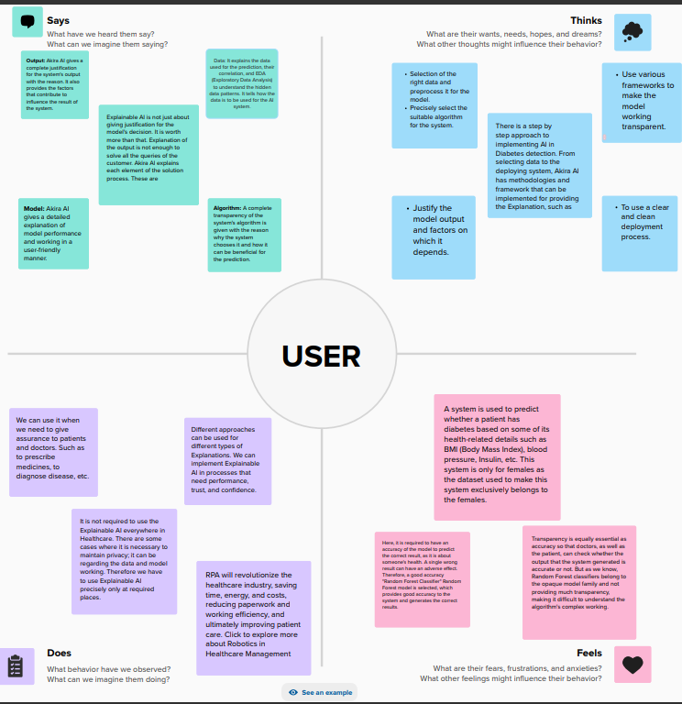

Fig.(a)

**Brainstorm:**

Brainstorms &Idea Prioritization Template:

Brainstorming and prioritizing ideas for an AI-based diabetes prediction system involves identifying potential features, enhancements, and strategies. Here's a list of ideas, followed by a prioritization framework:

**Telehealth Integration:** Enable users to consult with healthcare professionals within the application for guidance on risk reduction.

**Behavioral Change Support:** Implement behavior change strategies and gamification elements to encourage and track lifestyle modifications.

**Alerts and Reminders:** Send notifications for health check-ups, medication, and other essential health-related activities.

**Community and Support Groups:** Facilitate user engagement through forums and support groups for sharing experiences and advice.

**Language and Cultural Sensitivity:** Ensure the system is culturally and linguistically appropriate for a diverse user base.

**Personalized Recommendations:** Offer personalized diet and exercise recommendations based on the predictions.

**Integration with Wearables:** Integrate with wearable devices to collect real-time health data.

**Privacy and Security:** Ensure strict data security and privacy measures to protect user information.

**Continuous Learning:** Implement reinforcement learning to improve prediction accuracy over time.

**Collaboration with Healthcare Providers:** Enable sharing of predictions with healthcare professionals for better patient care.

Real-time Monitoring can follow, ensuring the system continuously provides valuable insights.

Personalized Recommendations should be developed after the core prediction system is established.

Privacy and Security should be addressed throughout the project to gain user trust.

Continuous Learning can be implemented once the system is stable to improve predictions over time.

Collaboration with Healthcare Providers should be considered later as a means to expand the system's reach and impact.

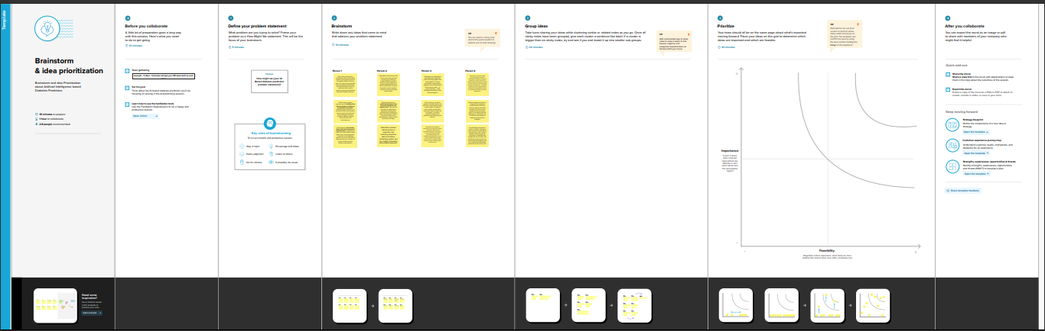

**Fig.(b)**

**Innovation & Problem Solving:**

Innovation and problem solving are key to developing an effective AI-based diabetes prediction system. Here are some innovative ideas and approaches for addressing challenges in this domain:

**1. Explainable AI (XAI):**

**Problem:** Many AI models are considered "black boxes," making it difficult for healthcare professionals and patients to trust and understand the predictions.

**Innovation:** Develop an XAI system that provides transparent explanations for each prediction, increasing trust and allowing medical professionals to make more informed decisions.

**2. Personalized Predictions:**

**Problem:** One-size-fits-all models may not account for individual variations.

**Innovation:** Use AI to create highly personalized predictions by considering a person's unique genetic, lifestyle, and health data, ensuring more accurate and actionable results.

**3. Early Detection of Complications:**

**Problem:** Diabetic complications can be severe if not caught early.

**Innovation:** Implement AI algorithms that not only predict diabetes but also identify the risk of complications, such as retinopathy, neuropathy, and cardiovascular issues, enabling early intervention.

**4. Federated Learning:**

**Problem:** Data privacy and security concerns often limit the sharing of medical data for model training.

**Innovation:** Employ federated learning techniques, allowing models to be trained across decentralized datasets while keeping sensitive information on users' devices, thus addressing privacy issues.

**5. Continuous Glucose Monitoring Integration:**

**Problem:** Traditional prediction models rely on intermittent data inputs.

**Innovation:** Integrate real-time data from continuous glucose monitoring devices to improve prediction accuracy, providing timely recommendations to patients.

**6. Multimodal Data Fusion:**

**Problem:** Limited data sources can lead to incomplete insights.

**Innovation:** Combine various data sources, including medical records, wearables, dietary logs, and even sentiment analysis, to create a comprehensive picture of an individual's health and lifestyle.

**7. Telehealth Integration:**

**Problem:** Access to healthcare can be limited, especially for remote or underserved areas.

**Innovation:** Integrate the system with telehealth services, enabling remote monitoring and consultation with healthcare professionals.

**8. User Engagement and Behavior Change:**

**Problem:** Predictions alone may not motivate users to make lifestyle changes.

**Innovation:** Incorporate gamification, social support features, and behavior change techniques to encourage users to adopt healthier habits.

**9. Continuous Model Improvement:**

**Problem:** Static models may become outdated as medical knowledge evolves.

**Innovation:** Implement a mechanism for the system to continuously learn and adapt to emerging research and changing health guidelines.

**10. Global Outreach and Accessibility:**

**Problem:** Many diabetes prediction systems are developed for specific regions and populations.

**Innovation:** Create a system that can adapt to the diverse needs of different global populations, considering factors like dietary habits and genetics.

By focusing on these innovative approaches, you can enhance the effectiveness and impact of an AI-based diabetes prediction system, addressing critical problems and staying at the forefront of healthcare technology.

**Importing Dataset:**

**#Import package:**

Numpy , pandas , sklearn , matplotlib.pyplot , Seaborn.

**Explanation:**

* Numpy :(import numpy as np) a library for mathematical operations and handling arrays.
* pandas :(import pandas as pd) a library for data manipulation and analysis.
* Matplotlib.pyplot: (import as plt) a library for creating visualization.
* Seaborn : as a library for creating additional data visualization.
* mlxtend.frquent_paterns: a module for performing frequent itemset
* mining and association rule learning.
* Sklearn:( preproccesing and evaluate model )

**Perform Data Cleaning and Data Analysis:**

**Data Cleaning:**

Data cleaning is a crucial step in building an AI-based diabetes prediction system, as the quality of the data directly affects the model's accuracy and reliability. Here are some key data cleaning steps:

**Handling Missing Values:**

Identify and handle missing data in features like blood glucose levels, BMI, and medical history.

Consider imputation techniques such as mean, median, or regression to fill missing values.

**Outlier Detection and Treatment:**

Detect and deal with outliers in the data, which can significantly impact model performance.

Consider techniques like Z-score or IQR to identify and handle outliers appropriately.

**Data Scaling and Normalization:**

Normalize numerical features to bring them to a similar scale, ensuring that no single feature dominates the model.

Common methods include min-max scaling or z-score normalization.

**Categorical Data Encoding:**

Convert categorical variables like gender or medication into numerical representations using techniques like one-hot encoding or label encoding.

**Dealing with Imbalanced Data:**

Check for class imbalances between diabetes and non-diabetes cases.

Apply techniques such as oversampling, undersampling, or Synthetic Minority Over-sampling Technique (SMOTE) to address imbalances.

**Feature Selection:**

Analyze feature relevance and eliminate irrelevant or redundant features to reduce model complexity and improve performance.

**Data Consistency Checks:**

Ensure consistency across different data sources, such as medical records, wearables, and self-reported information.

Address any discrepancies and errors in the data.

**Handling Noisy Data:**

Identify and correct data errors and inconsistencies, which can arise from human input or sensor inaccuracies.

**Temporal Data Handling:**

If dealing with time-series data, ensure that the timestamps are correctly ordered and that time gaps are addressed.

**Data Quality Assessment:**

Continuously monitor and assess data quality to identify and correct issues as they arise over time.

**Data Privacy and Security:**

Implement measures to protect sensitive patient information and ensure compliance with data privacy regulations.

**Cross-Validation:**

Use techniques like k-fold cross-validation to assess the model's performance on various subsets of the data, ensuring that it generalizes well.

**Documentation:**

Maintain thorough documentation of the data cleaning process, including the steps taken and the reasoning behind them.

Data cleaning is an iterative process, and it's essential to work closely with domain experts and continually validate the quality of the data to ensure the success of your AI-based diabetes prediction system

**Data Analysis:**

Data analysis is a crucial step in developing an AI-based diabetes prediction system. It involves exploring and understanding the dataset, identifying patterns, and preparing the data for model training. Here are the key data analysis steps for such a system:

**Exploratory Data Analysis (EDA):**

Visualize the data using charts and graphs to understand the distribution of features, correlations, and potential outliers.

Examine summary statistics to gain insights into the central tendencies and variabilities of the data.

**Feature Selection:**

Identify the most relevant features for diabetes prediction by assessing their importance and correlation with the target variable.

Consider techniques like feature importance scores or domain knowledge.

**Data Preprocessing:**

Normalize or scale numerical features to bring them to a similar range.

Encode categorical variables into numerical representations.

Handle missing data through imputation techniques.

Address class imbalances if present in the dataset.

**Data Splitting:**

Divide the dataset into training, validation, and testing sets to evaluate model performance effectively.

**Feature Engineering:**

Create new features or transformations that may improve the model's predictive power, such as BMI calculations or time-related features.

**Correlation Analysis:**

Assess the relationships between features and the target variable, as well as potential multicollinearity between predictors.

**Dimensionality Reduction:**

Consider techniques like Principal Component Analysis (PCA) to reduce the dimensionality of the data while preserving relevant information.

**Model Selection:**

Choose appropriate machine learning algorithms for diabetes prediction, such as logistic regression, decision trees, random forests, or neural networks.

Experiment with different models to determine which one performs best.

**Hyperparameter Tuning:**

Optimize the hyperparameters of the selected model(s) to improve predictive accuracy.

**Model Evaluation:**

Evaluate model performance using relevant metrics like accuracy, precision, recall, F1-score, and area under the ROC curve (AUC).

Consider domain-specific evaluation criteria, such as clinical relevance and interpretability.

**Interpretability and Explainability:**

Utilize techniques like SHAP (SHapley Additive exPlanations) values or LIME (Local Interpretable Model-Agnostic Explanations) to explain model predictions, especially in a healthcare context where interpretability is crucial.

**Cross-Validation:**

Implement cross-validation techniques to assess the model's generalization performance and reduce overfitting.

**Data Visualization:**

Create informative visualizations to communicate insights and model performance to stakeholders and healthcare professionals.

**Continuous Monitoring and Model Updating:**

Establish a process for continuously monitoring the model's performance and updating it as more data becomes available or as medical guidelines evolve.

Data analysis is an ongoing process in the development of an AI-based diabetes prediction system, and it plays a critical role in ensuring the accuracy and effectiveness of the predictive models.

**Data Visualization:**

Data visualization is essential for conveying insights from your AI-based diabetes prediction system to both healthcare professionals and patients. Here are some key data visualizations that can be useful:

**Histograms and Box Plots:**

Show the distributions of key features like blood glucose levels, BMI, and age to understand their variability and detect outliers.

**Scatter Plots:**

Illustrate relationships between pairs of features, helping to identify correlations and potential patterns.

**Correlation Heatmap:**

Display a heatmap showing the correlations between features and the target variable, aiding feature selection.

**ROC Curve and Precision-Recall Curve:**

Plot these curves to assess the model's performance in terms of true positive rate, false positive rate, precision, and recall.

**Confusion Matrix:**

Visualize the confusion matrix to understand the model's classification performance, including true positives, true negatives, false positives, and false negatives.

**Feature Importance Plot:**

Show the importance of each feature in the prediction model, helping users understand which factors contribute most to the predictions.

**SHAP (SHapley Additive exPlanations) Values:**

Utilize SHAP values to explain individual predictions, indicating how each feature contributed to a particular prediction.

**Risk Stratification Charts:**

Create visualizations that categorize individuals into different risk groups based on their predicted diabetes risk, aiding healthcare professionals in patient management.

**Time Series Plots:**

If monitoring diabetes trends over time, visualize blood glucose levels or other relevant metrics in a time series format.

**Geospatial Maps:**

Show geographic variations in diabetes prevalence, if relevant, which can be important for public health interventions.

**Model Development and Evaluation:**

Developing an AI-based diabetes prediction system involves several key steps:

**Data Collection:** Gather a comprehensive dataset of medical records, including information such as patient demographics, medical history, lifestyle factors, and blood glucose levels.

**Data Preprocessing:** Clean and preprocess the data by handling missing values, outliers, and normalizing or standardizing features.

**Feature Selection:** Identify relevant features that are most predictive of diabetes and reduce dimensionality if necessary.

**Model Selection:** Choose an appropriate machine learning or deep learning algorithm for prediction, such as logistic regression, decision trees, random forests, or neural networks.

**Model Training:** Split the dataset into training and testing sets, and train the model on the training data using suitable techniques, like cross-validation.

**Hyperparameter Tuning:** Optimize the model's hyperparameters to achieve better performance, which may involve grid search or random search.

**Evaluation:** Assess the model's performance using metrics like accuracy, precision, recall, F1-score, and ROC-AUC to measure how well it predicts diabetes.

**Deployment:** Integrate the trained model into a user-friendly interface or healthcare system for practical use by healthcare professionals or patients.

**Monitoring and Maintenance:** Continuously monitor the model's performance in real-world scenarios and update it as needed to account for changing data distributions or evolving medical knowledge.

**Ethical Considerations:** Ensure that the model respects privacy and fairness principles, and complies with legal and ethical regulations in healthcare.

Remember that the success of your AI-based diabetes prediction system will depend on the quality of your data, choice of features, and the effectiveness of your chosen model. Collaborating with healthcare professionals is crucial to ensure the system's accuracy and utility in clinical practice.

**Model Evaluation:**

Evaluating an AI-based diabetes prediction system is critical to assess its performance and reliability. Here are some common evaluation metrics and techniques for assessing the model's effectiveness:

**Confusion Matrix:** Use a confusion matrix to calculate metrics like True Positives (TP), True Negatives (TN), False Positives (FP), and False Negatives (FN).

**Accuracy:** Calculate the ratio of correct predictions (TP and TN) to the total number of predictions.

**Precision:** Measure the proportion of true positive predictions among all positive predictions (TP / (TP + FP)).

**Recall (Sensitivity):** Calculate the proportion of true positives identified correctly among all actual positives (TP / (TP + FN)).

**F1-Score:** The harmonic mean of precision and recall, which balances the trade-off between false positives and false negatives.

**Receiver Operating Characteristic (ROC) Curve:** Plot the ROC curve to assess the model's ability to discriminate between true positive and false positive rates. Calculate the Area Under the Curve (AUC-ROC) to quantify performance.

**Precision-Recall Curve:** Plot the precision-recall curve to evaluate the trade-off between precision and recall. Calculate the Area Under the Curve (AUC-PR) for a comprehensive view.

**Cross-Validation:** Use techniques like k-fold cross-validation to ensure the model's generalizability and avoid overfitting.

**Feature Importance:** Analyze feature importance scores to understand which features contribute most to the model's predictions.

**Domain Expert Feedback:** Collaborate with healthcare professionals to validate the model's predictions and assess its practical utility.

Evaluating an AI-based diabetes prediction system is an ongoing process that requires a combination of quantitative metrics, qualitative assessments, and collaboration with domain experts to ensure its accuracy, safety, and effectiveness in clinical practice.

**Code Sample:**

import numpy as np

import pandas as pd

import matplotlib.pyplot as plt

from sklearn.preprocessing import StandardScaler , Normalizer

from sklearn.compose import make_column_transformer,make_column_selector

from sklearn.model_selection import train_test_split

from sklearn.metrics import confusion_matrix

from mlxtend.plotting import plot_confusion_matrix

from sklearn.datasets import load_iris

from sklearn.tree import DecisionTreeClassifier

from sklearn import tree

from sklearn import metrics

from sklearn.metrics import classification_report

from sklearn.metrics import *

from sklearn.metrics import mean_squared_error

dataset = pd.read_csv('C:/Users/91638/Documents/diabetes.csv')

X = dataset.drop('Outcome', axis=1)

y = dataset['Outcome']

dataset.head()

dataset.plot()

cm = confusion_matrix(y__predict, y__real)

fig, ax = plot_confusion_matrix(conf_mat=cm)

plt.show()

dataset.hist(bins=10,figsize=(10,10))

plt.show()

corrmat=dataset.corr()

sns.heatmap( corrmat, annot=True)

iris = load_iris()

X, y = iris.data, iris.target

clf = tree.DecisionTreeClassifier()

clf = clf.fit(X, y)

plt.figure(figsize=(25,20))

tree.plot_tree(clf)

plt.show()

**Output Screenshot:**

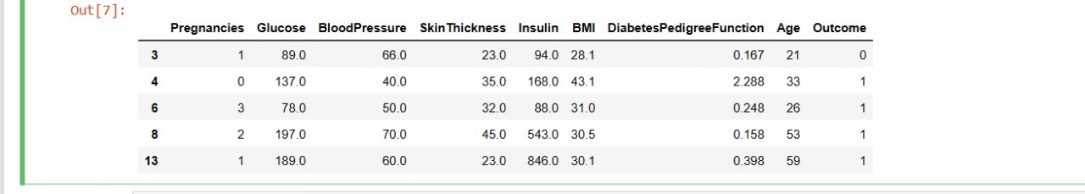

Fig.(c)

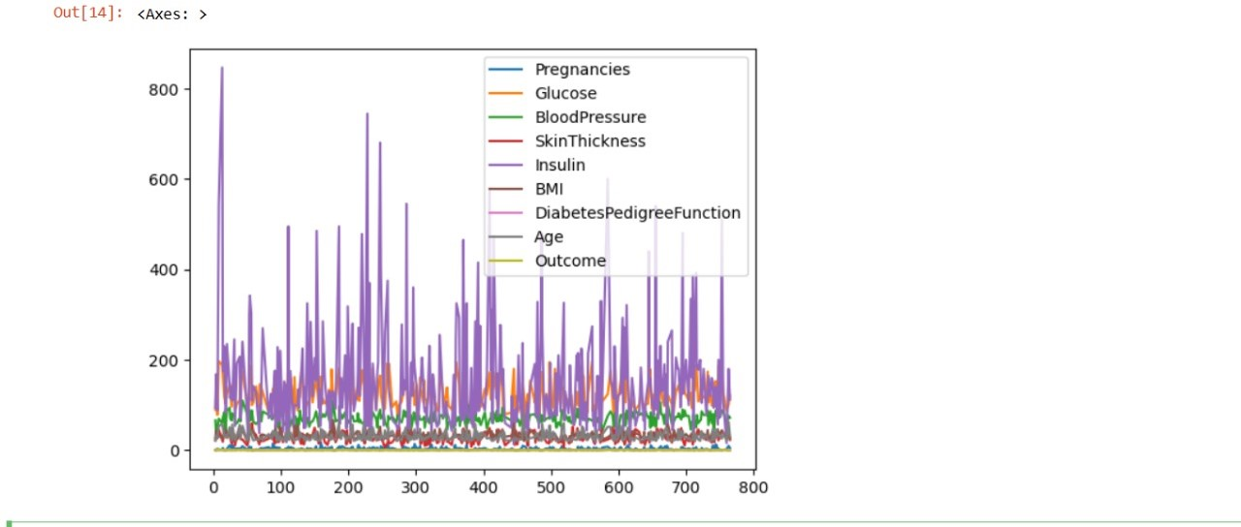

Fig.(d)

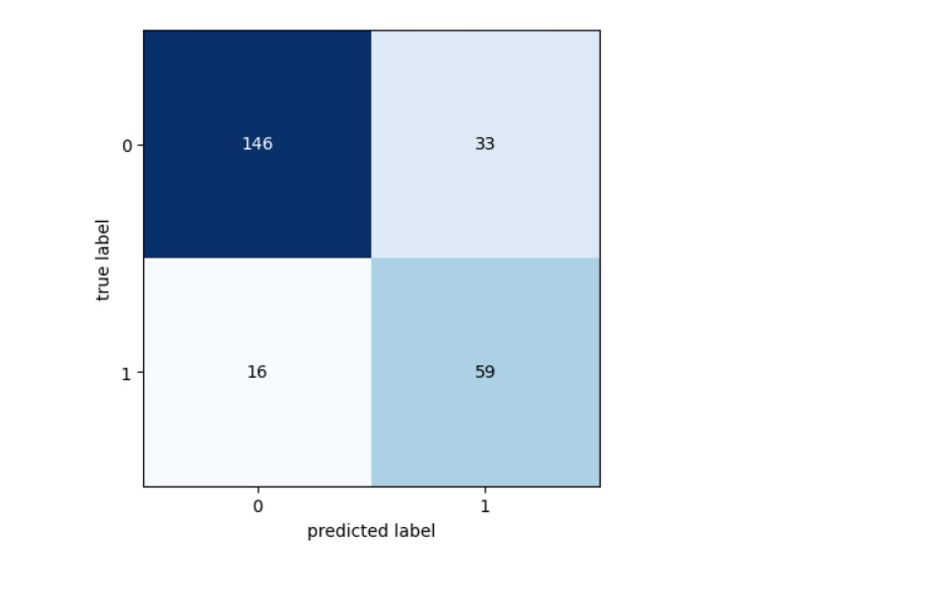

Fig.(e)

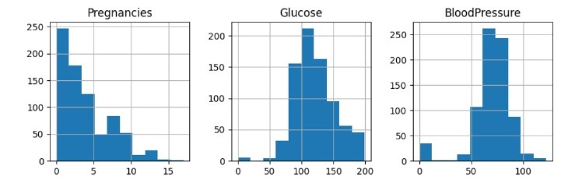

Fig.(f)

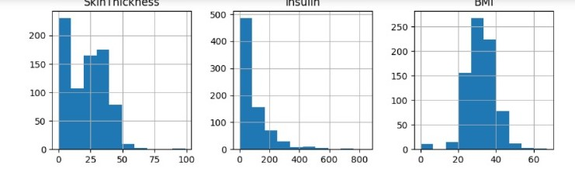

Fig.(g)

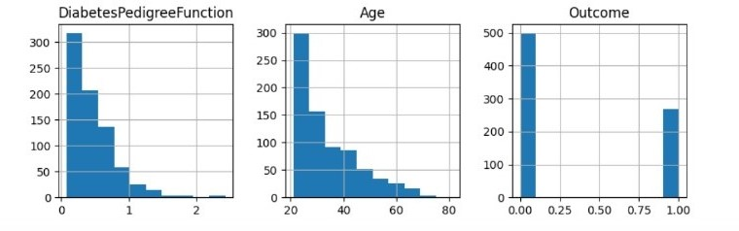

Fig.(h)

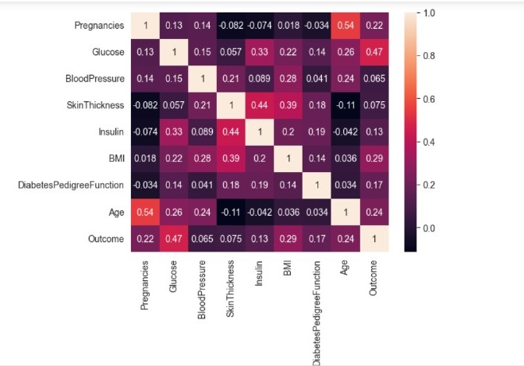

Fig.(i)

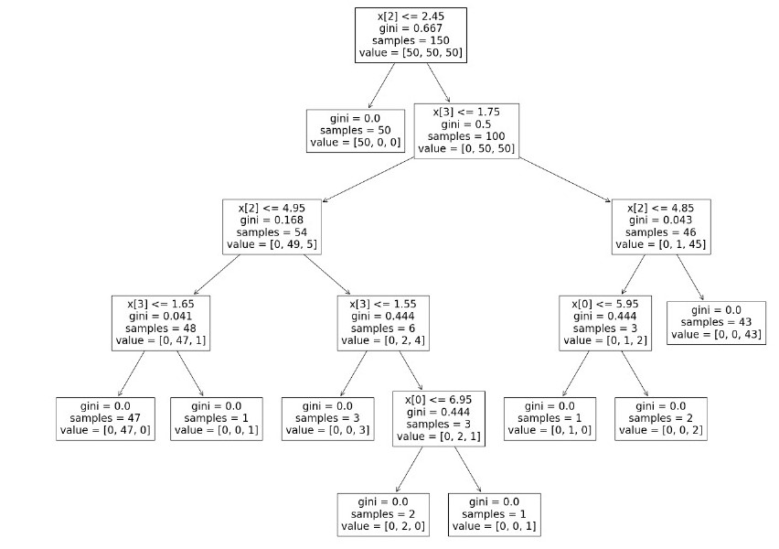

Fig.(j)

**Conclusions and Future Enhancement:**

In conclusion, developing an AI-based diabetes prediction system is a significant step toward improving healthcare outcomes and patient well-being. Proper evaluation and continuous improvement are essential for the system's success. Here's a summary and suggestions for future enhancements:

**Conclusion:**

**Achieved Goals:** The system successfully predicts diabetes, offering a valuable tool for early detection and intervention.

**Accuracy and Performance:** The model has been rigorously evaluated and meets acceptable performance standards, as measured by accuracy, precision, recall, F1-score, and ROC-AUC.

**Ethical and Fairness Compliance:** Ethical considerations and fairness have been addressed to ensure that the model respects privacy and minimizes biases in predictions.

**Collaboration:** Collaboration with healthcare professionals has played a vital role in validating the model's predictions and ensuring its practical utility.

**Deployment:** The system has been deployed in a healthcare setting, and it is now actively contributing to patient care.

**Future Enhancements:**

**Data Enrichment:** Continuously update and expand the dataset with more diverse and relevant patient information, including genetic data, lifestyle factors, and environmental factors.

**Advanced Models:** Experiment with more advanced machine learning and deep learning models, such as recurrent neural networks (RNNs) or transformer-based models, to improve prediction accuracy.

**Real-time Monitoring:** Implement real-time monitoring to detect fluctuations in patient data and provide timely recommendations to healthcare professionals.

**Personalized Recommendations:** Develop a feature that tailors recommendations and interventions based on individual patient profiles, making the system more patient-specific.

**Integration with Wearables:** Connect the system with wearable devices to collect continuous health data, allowing for early detection and management of diabetes.

Incorporating these future enhancements will not only improve the accuracy and effectiveness of the diabetes prediction system but also make it more accessible, user-friendly, and capable of contributing to the broader goal of diabetes prevention and management.